OFFICIAL COORDINATION REQUEST FOR
NON-ROUTINE OPERATIONS AND MAINTENANCE

COORDINATION TITLE- 22TDA07 MOC Shed Placement at Westrick Park
COORDINATION DATE- 6/7/2022
PROJECT- The Dalles Dam
RESPONSE DATE- 6/21/2022

Description of the problem - The purpose of this project is to provide needed storage space for Westrick Conference center by placing a prefabricated storage shed immediately adjacent to the building (Fig. 1). Installation of the shed will require construction of a 22’x38’x8” pad. Gravel will be placed in the excavated area: 2-3 inches of pit-run gravel will line the bottom of the area, then 5-6 inches ¾- gravel will be placed on the surface.
Type of outage required – no outage.

Impact on facility operation – Working outside of the IWW period excavating ground for the preparation of placing a storage shed.

Dates of impacts/repairs: ASAP - Summer 2022

Length of time for repairs – ~2 days

Analysis of potential impacts to fish

- 10-year average passage by run during the period of impact for adults and juvenile listed species, as appropriate for the proposed action and time of year; Sockeye peak 6/28 at 13K/day. Steelhead start increasing end of June into triple digits. Summer Chinook continue 1-2K/day through the summer. First week of Aug is normal dip between summer and fall runs.
- Statement about the current year’s run (e.g., higher or lower than 10-year average); Spring chinook was above average. Others are expected average, with Coho expected higher than average.
- Estimated exposure to impact by species and age class (i.e., number or percentage of run exposed to an impact by the action); No impact is expected. Approximately 10% of all east fishladder passage goes through the south channel near Westrick. The surface of the water is ~50’ from the actual work location if you factor in both horizontal and vertical. The depth in the channel is ~15’. Most passing fish will likely be >50’.
- Type of impact by species and age class (increased delay, exposure to predation, exposure to a route of higher injury/mortality rate, exposure to higher TDG, etc.); The concern is potential of noise impact to migrating adults in the south channel from the excavation work.

Summary statement - expected impacts on:
No impacts are expected to fish passage, regardless of time and date of work. Research supporting this FPP 50’ distance requirement is lacking. Anecdotal evidence supports passing fish tolerate much more than expected. Furthermore, vibration distance is highly dependent on substrate component. This excavation area is soft ground and shallow, therefore vibration should be minimal or non-existent. It will likely be similar to routine work that occurs in this area. Only ~10% of total east fish ladder passage passes this location.

Comments from agencies

Final coordination results

Please email or call with questions or concerns.
Thank you,

Bob Cordie
Project Biologist – The Dalles Dam
Robert.P.Cordie@usace.army.mil

Patricia Madson
Columbia River Coordination (acting)
Patricia.L.Madson@usace.army.mil

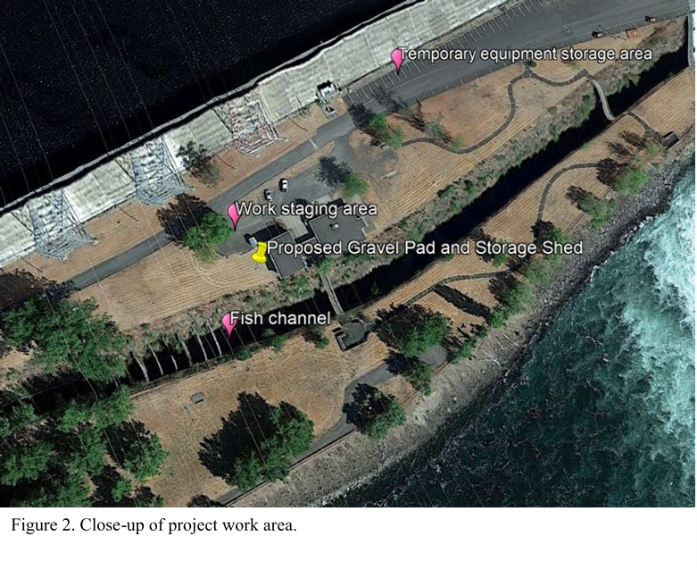

Figure 1. Close up of work area.

